2023 Midsouth Women’s Herbal Conference Vendor Information and Application
Application on page 3

Please Read Before Proceeding: We are so grateful for vendors who have supported us and participated in this amazing conference in the past! We cannot wait to review applications for 2023 and start building next year’s marketplace. In the past, the most common dilemma vendors have had is this: do I want to attend to vend OR do I want to attend and go to workshops? Fortunately, we have found a structure that allows vendors to do both! On Friday and Saturday, there are dedicated Marketplace Hours when no other workshops are going on. It is up to you whether you vend outside of these hours or not. We tested this out at our small 2021 conference, and vendors reported higher sales and more fun than past conferences when booths were open throughout the weekend. We always end up with a waiting list, so apply early! We only accept a couple vendors in each “category” (such as “books”) to ensure a profitable experience for everyone.

General Vendor Information
- Vending booths are inside an open-air pavilion. Electricity requires advanced request.
- Vendors are provided one booth space, approximately 10ft in width, and two chairs. You are allowed to bring one 6- or 8-foot table + shelves or racks. A second table needs to be approved. If you cannot bring your own table, please request one on your application.
- Wi-Fi access is NOT available in the vendor area. AT&T phones tend to have some service, however most others do not. You will need to be prepared to take cash and/or check payments.

Vendor Setup Requirements
- Vendor setup is from 9:00am-2:00pm on Friday, September 29. Thursday setup may be possible if you are arriving on Thursday.
- All vehicles, trailers and non-registered assistants must be moved from the marketplace area by 11:30am on Friday morning. Exceptions must be approved in advance.
- Booths must be staffed during Marketplace Hours. This includes Friday night’s Marketplace Mingle and Saturday afternoon’s Open Marketplace. Vending at other times is optional.

Vendor Eligibility and General Guidelines
- Vendors must represent an established business or service.
- The submission of vendor application form does not guarantee a vendor space. You will receive a confirmation email verifying your application has been received.
- Selections will be made as we receive applications. Once accepted, vendors must register and pay by February 1, 2023, to secure their spot. Any approvals after February 1 require payment within 1 week of approval. If payment is not received within this time frame, the spot will be offered to someone else.
- Vendors are responsible for their own payment processing, providing change to customers and collecting/reporting sales tax, if applicable. Internet and cell coverage is extremely limited at Camp Woodmont, so we encourage vendors to take cash and checks.
- Tables are no longer automatically provided, however, if you cannot provide your own, we may be able to assist; please ask about this in advance. We allow one table per booth + shelves or small accent tables.
- Vendors must cover their table(s) with fabric tablecloths. No plastic tablecloths are allowed.
- Vendors may not conduct business or tear down booths during special events being held in the vending space that take place outside of Marketplace hours. If a workshop or event is being held in the gym, vendors must close their booths to support a quiet environment.
- Vendors must agree to abide by camp and conference policies, specifically but not limited to, Camp Woodmont’s “no drug, alcohol, or smoking on campus policy.”

2023 Vending Fees and Optional Items
Vending Type | Includes | Cost
Commuting Vendor | Commuter Registration ($295)  Vendor booth + 2 chairs ($40)  Parking for 1 vehicle (complimentary) | $335.00
Standard Vendor  (Camping) | Camping Registration ($395)  Vendor booth + 2 chairs ($40)  Parking for 1 vehicle (complimentary) | $435.00
Standard Vendor  (Shared Cabin) | Shared Cabin Registration ($425)  Vendor booth + 2 chairs ($40)  Parking for 1 vehicle (complimentary) | $465.00
Standard Vendor  (Private Cabin) | Private Cabin Registration ($515)  Vendor booth + 2 chairs ($40)  Parking for 1 vehicle (complimentary) | $555.00
Table Rental | (1) 8-foot table | $15.00
Optional Meal Plan | 5 Meals: Friday Dinner - Sunday Breakfast | $65.00

Vendor Cancellations and Refunds
Vendor refunds are subject to the same refund policy as standard conference registrations. No refunds are available after registration unless the event is cancelled.

Marketplace Photos
Pictures: the open-air gym (known to us as the Green Goddess Pavilion) and booth examples

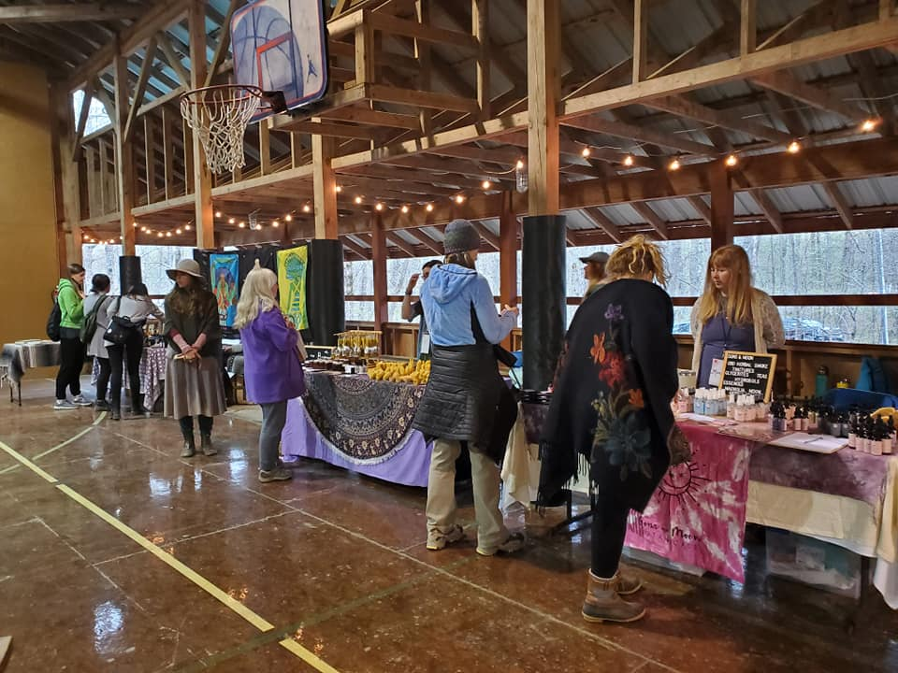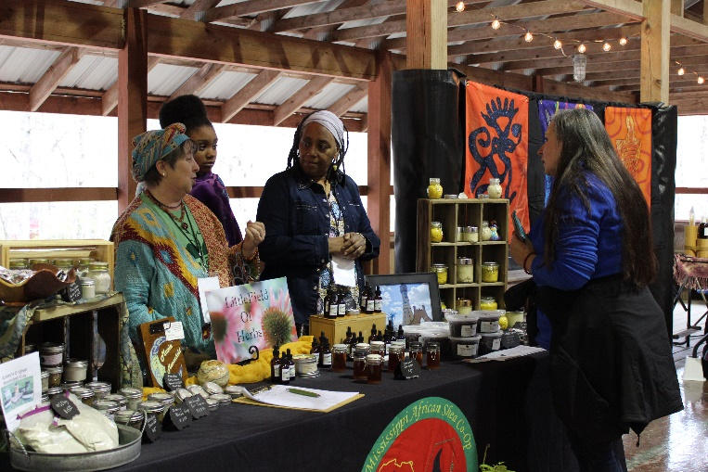

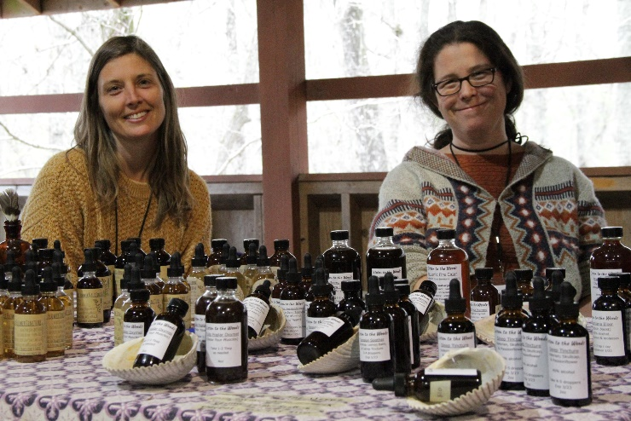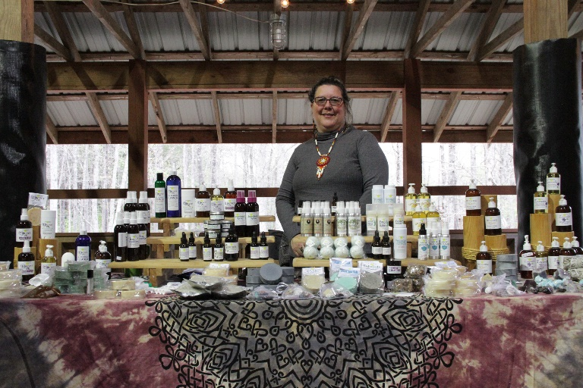

2023 Midsouth Women’s Herbal Conference Vendor Information and Application
*please read pages 1-2 of this document before applying*
Submission Instructions:
- Please complete all fields in the form below.
- We will make selections as we receive applications, and we will continue to accept applications until we have all spots filled.
- Email completed form to midsouthwomensherbalconference@gmail.com.
- During winter 2022-2023, our office hours are limited. Please allow 3-5 business days for a reply.

Vendor Company Name
Owner/Contact Name
Email
Phone Number
Street Address
City, State, Zip
Website, Etsy or Facebook Link, if applicable
Products or services you would like to offer: please be specific and descriptive and/or attach photos to your email.
Have you vended at any similar events? If so, please describe.
Do you understand the 2023 Vendor Guidelines as outlined on pages 1-2 of this document?
Are you prepared to pay your registration and vendor fee no later than February 1, 2023?
Will you be bringing your own table or would you like to rent one from us?
Optional: Is there any other information you would like us to know?

